AUTOMATIC RAILWAY GATE CONTROL WITH IR SENSOR

Abstract
The objective of this paper is to provide an automatic railway gate at a level crossing replacing the gates operated by the gatekeeper. The system reduces the time for which the gate remains closed. This type of gates can be employed in an unmanned level crossing where the chances of accidents are higher and reliable operation is required. Since, the operation is automatic, error due to manual operation is prevented. The system works on a microcontroller based control.The proposed system uses ATmega 16A microcontroller. With the help of IR sensor. The arrival and leaving of the system is monitored and the gate is operated accordingly.

1. INTRODUCTION
Railroad is one of the transient mode which has an important role in moving passengers and freights. However railroad accidents are more dangerous than other transportation accidents in terms of severity and death rate etc. Now-a-days India is the country which having world‟s largest railway network. Over hundreds of railway running on track every day. As we know that it is surely impossible to stop, the running train at instant is some critical situation or emergency arises. Train accidents having serious repercussions in terms of loss of human life injury, damage to railway property. This includes the collision of trains at level crossings. In our country it is a progressive country. It has already enough economical problems which are ever been unsolved. To avoid all these things some sort of automatic and independent system comes. There are mainly two types of level crossings. They are manned level crossings and unmanned level crossings.
An embedded system is a combination of software and hardware to perform a dedicated task. Some of the main devices used in embedded products are Microprocessors and Microcontrollers. Microprocessors are commonly referred to as general purpose processors as they simply accept the inputs, process it and give the output. In contrast, a microcontroller not only accepts the data as inputs but also manipulates it, interfaces the data with various devices, controls the data and thus finally gives the result.
1.1 Introduction of Embedded System:
An Embedded System is a combination of computer hardware and software, and perhaps additional mechanical or other parts, designed to perform a specific function. A good example is the microwave oven. Almost every household has one, and tens of millions of them are used every day, but very few people realize that a processor and software are involved in the preparation of their lunch or dinner.
This is in direct contrast to the personal computer in the family room. It too is comprised of computer hardware and software and mechanical components (disk drives, for example). However, a personal computer is not designed to perform a specific function rather; it is able to do many different things. Many people use the term general-purpose computer to make this distinction clear. As shipped, a general-purpose computer is a blank slate; the manufacturer does not know what the customer will do wish it. One customer may use it for a network file server another may use it exclusively for playing games, and a third may use it to write the next great American novel.
Frequently, an embedded system is a component within some larger system. For example, modern cars and trucks contain many embedded systems. One embedded system controls the antilock brakes, other monitors and controls the vehicle's emissions, and a third displays information on the dashboard. In some cases, these embedded systems are connected by some sort of a communication network, but that is certainly not a requirement.
At the possible risk of confusing you, it is important to point out that a general-purpose computer is itself made up of numerous embedded systems. For example, my computer consists of a keyboard, mouse, video card, modem, hard drive, floppy drive, and sound card-each of Which is an embedded system? Each of these devices contains a processor and software and is designed to perform a specific function. For example, the modem is designed to send and receive digital data over analog telephone line. That's it and all of the other devices can be summarized in a single sentence as well.
If an embedded system is designed well, the existence of the processor and software could be completely unnoticed by the user of the device. Such is the case for a microwave oven, VCR, or alarm clock. In some cases, it would even be possible to build an equivalent device that does not contain the processor and software. This could be done by replacing the combination with a custom integrated circuit that performs the same functions in hardware. However, a lot of flexibility is lost when a design is hard-cooled in this way. It is mush easier, and cheaper, to change a few lines of software than to redesign a piece of custom hardware.
1.2 History and Future:
Given the definition of embedded systems earlier is this chapter; the first such systems could not possibly have appeared before 1971. That was the year Intel introduced the world's first microprocessor. This chip, the 4004, was designed for use in a line of business calculators produced by the Japanese Company Busicom. In 1969, Busicom asked Intel to design a set of custom integrated circuits-one for each of their new calculator models. The 4004 was Intel's response rather than design custom hardware for each calculator, Intel proposed a general-purpose circuit that could be used throughout the entire line of calculators. Intel's idea was that the software would give each calculator its unique set of features.
The microcontroller was an overnight success, and its use increased steadily over the next decade. Early embedded applications included unmanned space probes, computerized traffic lights, and aircraft flight control systems. In the 1980s, embedded systems quietly rode the waves of the microcomputer age and brought microprocessors into every part of our kitchens (bread machines, food processors, and microwave ovens), living rooms (televisions, stereos, and remote controls), and workplaces (fax machines, pagers, laser printers, cash registers, and credit card readers).
It seems inevitable hat the number of embedded systems will continue to increase rapidly. Already there are promising new embedded devices that have enormous market potential; light switches and thermostats that can be central computer, intelligent air-bag systems that don't inflate when children or small adults are present, pal-sized electronic organizers and personal digital assistants (PDAs), digital cameras, and dashboard navigation systems. Clearly, individuals who possess the skills and desire to design the next generation of embedded systems will be in demand for quite some time.
1.3 Real Time Systems:
One subclass of embedded is worthy of an introduction at this point. As commonly defined, a real-time system is a computer system that has timing constraints. In other words, a real-time system is partly specified in terms of its ability to make certain calculations or decisions in a timely manner. These important calculations are said to have deadlines for completion. And, for all practical purposes, a missed deadline is just as bad as a wrong answer.
The issue of what if a deadline is missed is a crucial one. For example, if the real-time system is part of an airplane's flight control system, it is possible for the lives of the passengers and crew to be endangered by a single missed deadline. However, if instead the system is involved in satellite communication, the damage could be limited to a single corrupt data packet. The more severe the consequences, the more likely it will be said that the deadline is "hard" and thus, the system is a hard real-time system. Real-time systems at the other end of this discussion are said to have "soft" deadlines.
All of the topics and examples presented in this book are applicable to the designers of real-time system who is more delight in his work. He must guarantee reliable operation of the software and hardware under all the possible conditions and to the degree that human lives depend upon three system's proper execution, engineering calculations and descriptive paperwork.
Application Areas :Nearly 99 per cent of the processors manufactured end up in embedded systems. The embedded system market is one of the highest growth areas as these systems are used in very market segment- consumer electronics, office automation, industrial automation, biomedical engineering, wireless communication,Data communication, telecommunications, transportation, military and so on.
Consumer appliances: At home we use a number of embedded systems which include digital camera, digital diary, DVD player, electronic toys, microwave oven, remote controls for TV and air-conditioner, VCO player, video game consoles, video recorders etc. Today’s high-tech car has about 20 embedded systems for transmission control, engine spark control, air-conditioning, navigation etc. Even wristwatches are now becoming embedded systems. The palmtops are powerful embedded systems using which we can carry out many general-purpose tasks such as playing games and word processing.
Office automation: The office automation products using em embedded systems are copying machine, fax machine, key telephone, modem, printer, scanner etc.
Industrial automation: Today a lot of industries use embedded systems for process control. These include pharmaceutical, cement, sugar, oil exploration, nuclear energy, electricity generation and transmission. The embedded systems for industrial use are designed to carry out specific tasks such as monitoring the temperature, pressure, humidity, voltage, current etc., and then take appropriate action based on the monitored levels to control other devices or to send information to a centralized monitoring station. In hazardous industrial environment, where human presence has to be avoided, robots are used, which are programmed to do specific jobs. The robots are now becoming very powerful and carry out many interesting and complicated tasks such as hardware assembly.
Medical electronics: Almost every medical equipment in the hospital is an embedded system. These equipments include diagnostic aids such as ECG, EEG, blood pressure measuring devices, X-ray scanners; equipment used in blood analysis, radiation, colonoscopy, endoscopy etc.
Developments in medical electronics have paved way for more accurate diagnosis of diseases.
Computer networking: Computer networking products such as bridges, routers, Integrated
Services Digital Networks (ISDN), Asynchronous Transfer Mode (ATM), X.25 and frame relay switches are embedded systems which implement the necessary data communication protocols. For example, a router interconnects two networks. The two networks may be running different protocol stacks. The router’s function is to obtain the data packets from incoming pores, analyze the packets and send them towards the destination after doing necessary protocol conversion. Most networking equipments, other than the end systems (desktop computers) we use to access the networks, are embedded systems.
Telecommunications: In the field of telecommunications, the embedded systems can be categorized as subscriber terminals and network equipment. The subscriber terminals such as key telephones, ISDN phones, terminal adapters, web cameras are embedded systems. The network equipment includes multiplexers, multiple access systems, Packet Assemblers Dissemblers (PADs), sate11ite modems etc. IP phone, IP gateway, IP gatekeeper etc. are the latest embedded systems that provide very low-cost voice communication over the Internet.
Wireless technologies: Advances in mobile communications are paving way for many interesting applications using embedded systems. The mobile phone is one of the marvels of the last decade of the 20’h century. It is a very powerful embedded system that provides voice communication while we are on the move. The Personal Digital Assistants and the palmtops can now be used to access multimedia services over the Internet. Mobile communication infrastructure such as base station controllers, mobile switching centers are also powerful embedded systems.
Insemination:Testing and measurement are the fundamental requirements in all scientific and engineering activities. The measuring equipment we use in laboratories to measure parameters such as weight, temperature, pressure, humidity, voltage, current etc. are all embedded systems. Test equipment such as oscilloscope, spectrum analyzer, logic analyzer, protocol analyzer, radio communication test set etc. are embedded systems built around powerful processors. Thank to miniaturization, the test and measuring equipment are now becoming portable facilitating easy testing and measurement in the field by field-personnel.
Security: Security of persons and information has always been a major issue. We need to protect our homes and offices; and also the information we transmit and store. Developing embedded systems for security applications is one of the most lucrative businesses nowadays. Security devices at homes, offices, airports etc. for authentication and verification are embedded systems. Encryption devices are nearly 99 per cent of the processors that are manufactured end up in~ embedded systems. Embedded systems find applications in. every industrial segment- consumer electronics, transportation, avionics, biomedical engineering, manufacturing, process control and industrial automation, data communication, telecommunication, defense, security etc. Used to encrypt the data/voice being transmitted on communication links such as telephone lines.Biometric systems using fingerprint and face recognition are now being extensively used for user authentication in banking applications as well as for access control in high security buildings.
Finance: Financial dealing through cash and cheques are now slowly paving way for transactions using smart cards and ATM (Automatic Teller Machine, also expanded as Any Time Money) machines. Smart card, of the size of a credit card, has a small micro-controller and memory; and it interacts with the smart card reader! ATM machine and acts as an electronic wallet. Smart card technology has the capability of ushering in a cashless society. Well, the list goes on. It is no exaggeration to say that eyes wherever you go, you can see, or at least feel, the work of an embedded system.
1.4 Overview of Embedded System Architecture
Every embedded system consists of custom-built hardware built around a Central Processing Unit (CPU). This hardware also contains memory chips onto which the software is loaded. The software residing on the memory chip is also called the ‘firmware’. The embedded system architecture can be represented as a layered architecture as shown in Fig.
The operating system runs above the hardware, and the application software runs above the operating system. The same architecture is applicable to any computer including a desktop computer. However, there are significant differences. It is not compulsory to have an operating system in every embedded system.
For small appliances such as remote control units, air conditioners, toys etc., there is no need for an operating system and you can write only the software specific to that application. For applications involving complex processing, it is advisable to have an operating system. In such a case, you need to integrate the application software with the operating system and then transfer the entire software on to the memory chip. Once the software is transferred to the memory chip, the software will continue to run fora long time you don’t need to reload new software.
Now, let us see the details of the various building blocks of the hardware of an embedded system. As shown in Fig. the building blocks are:
- Central Processing Unit (CPU)
- Memory (Read-only Memory and Random Access Memory)
- Input Devices
- Output devices
- Communication interfaces
- Application-specific circuitry
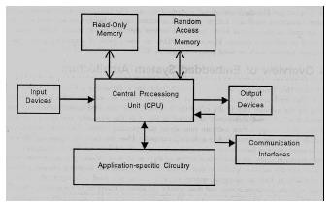
Fig 1.1 Blocks of hardware embedded system
Central Processing Unit (CPU):
The Central Processing Unit (processor, in short) can be any of the following:
microcontroller, microprocessor or Digital Signal Processor (DSP). A micro-controller is a lowcost processor. Its main attraction is that on the chip itself, there will be many other components such as memory, serial communication interface, analog-to digital converter etc. So, for small applications, a micro-controller is the best choice as the number of external components required will be very less. On the other hand, microprocessors are more powerful, but you need to use many external components with them. D5P is used mainly for applications in which signal processing is involved such as audio and video processing.
Memory:
The memory is categorized as Random Access 11emory (RAM) and Read Only Memory
(ROM). The contents of the RAM will be erased if power is switched off to the chip, whereas
ROM retains the contents even if the power is switched off. So, the firmware is stored in the ROM.
When power is switched on, the processor reads the ROM; the program is program is executed.

Input devices:
Unlike the desktops, the input devices to an embedded system have very limited capability. There will be no keyboard or a mouse, and hence interacting with the embedded system is no easy task. Many embedded systems will have a small keypad-you press one key to give a specific command. A keypad may be used to input only the digits. Many embedded systems used in process control do not have any input device foruser interaction; they take inputs fromsensors or transducers 1’fnd produce electrical signals that are in turn fed to other systems.
Output devices:
The output devices of the embedded systems also have very limited capability. Some embedded systems will have a few Light Emitting Diodes (LEDs) to indicate the health status of the system modules, or for visual indication of alarms. A small Liquid Crystal Display (LCD) may also be used to display some important parameters.
Communication interfaces:
The embedded systems may need to, interact with other embedded systems at they may have to transmit data to a desktop. To facilitate this, the embedded systems are provided with one or a few communication interfaces such as RS232, RS422, RS485, Universal Serial Bus (USB), IEEE 1394, Ethernet etc.
Application-specific circuitry:
Sensors, transducers, special processing and control circuitry may be required fat an embedded system, depending on its application. This circuitry interacts with the processor to carry out the necessary work. The entire hardware has to be given power supply either through the 230 volts main supply or through a battery. The hardware has to design in such a way that the power consumption is minimized.

LITRATURE SURVEY
When the train was passed in one station then the information will comes to the station master by the phone the gateman will receive the call and then gates will be closed.To overcome problem of Sensor technology is used.The two sensors are placed on both side of the gate upside and downside of the train direction with some distance like one sensor is place 5km distance from the gate for coming side of gate and another is placed at 1km from the gate. sensors are fixed both sides of the gate when the upside sensor gates activated the sensor gates activated thee sensed signal is sent to the microcontroller and the gates to be closed until the train crosses the gates and reaches after down sensor .when the down sensor activates the signal departures is sent to microcontroller motor turns is opposite direction and gates will be opened automatically. The disadvantage is when any person is moving at that place the gate is closed. To overcome this problems by using IR Sensor and microcontroller. The two sensors are placed on either side of the gate to magnet sensors is fixed at upside and downside of the train direction. sensors are fixed both sides of the gate when the upside sensor gates activated the sensor gates activated thee sensed signal is sent to the microcontroller and the gates to be closed until the train crosses the gates and reaches after down sensor .when the down sensor activates the signal departures is sent to microcontroller motor turns is opposite direction and gates will be opened automatically .
- To protect the vehicle and tracking so many advanced technologies are available in now a days. In olden days the information of accident can be transferred, but the place of accident spot cannot be identified. In any vehicle airbags are designed, air bags are used for security and safety travels The air bag system was introduced in the year of 1968.
- TPMS is system designed to control the pressure inside the pneumatic tires on vehicles that provides different operating conditions such as a lower tire pressure is desired in order to maximize traction, maneuvering through challenging terrain, pulling a heavy load out of an incline at slow speeds, crawling out of soft dirt. The pressure ranges from 15 to 45 PSI.
- Many other systems have been proposed to deduce the accident. The existing system deals with two sensors where MEMS sensor is used to detect the angle and vibration sensor is used for detection the change in the vehicle.
- The other existing system uses IOT and cloud computing system. Where the vehicle detection id done through SVM (support vehicle machine) that is developed by Ant Colony Algorithm (ACA). Here IOT will monitor the vehicles using magneto resistive sensors. The main aim of this project is to differentiate the accidents which took place in traffic and at no traffic place.
- Existing system also provides the location of the accident using Atmega 328 Microcontroller and RF transmitter and receiver. The information is send to the saved mobile numbers[3].

ARDUINO UNO

POWER
SUPPLY

IR SENSOR 1

LED

2. BLOCK DIAGRAM OF PROJECT AND FUNCTIONING
BLOCK DIAGRAM:

SERVO
MOTOR

IR SENSOR 2

POWER SUPPLY BLOCKDIAGRAM:

Step
down
Transformer

Filter

Regulator

Output

Bridge
Rectifier

3. DESCRPTION OF COMPONENTS
3.1 Arduino.
Overview The Arduino Uno is a microcontroller board based on the ATmega328 (datasheet). It has 14 digital input/output pins (of which 6 can be used as PWM outputs), 6 analog inputs, a 16 MHz ceramic resonator, a USB connection, a power jack, an ICSP header, and a reset button. It contains everything needed to support the microcontroller; simply connect it to a computer with a USB cable or power it with a AC-to-DC adapter or battery to get started. The Uno differs from all preceding boards in that it does not use the FTDI USB-to-serial driver chip. Instead, it features the Atmega16U2 (Atmega8U2 up to version R2) programmed as a USB-to-serial converter. Revision 2 of the Uno board has a resistor pulling the 8U2 HWB line to ground, making it easier to put into DFU mode. Revision 3 of the board has the following new features:
• 1.0 pinout: added SDA and SCL pins that are near to the AREF pin and two other new pins placed near to the RESET pin, the IOREF that allow the shields to adapt to the voltage provided from the board. In future, shields will be compatible both with the board that use the AVR, which operate with 5V and with the Arduino Due that operate with 3.3V. The second one is a not connected pin, that is reserved for future purposes.
•Stronger RESET circuit.
•Atmega 16U2 replace the 8U2. "Uno" means one in Italian and is named to mark the upcoming release of Arduino 1.0. The Uno and version 1.0 will be the reference versions of Arduino, moving forward. The Uno is the latest in a series of USB Arduino boards, and the reference model for the Arduino platform; for a comparison with previous versions, see the index of Arduino boards.
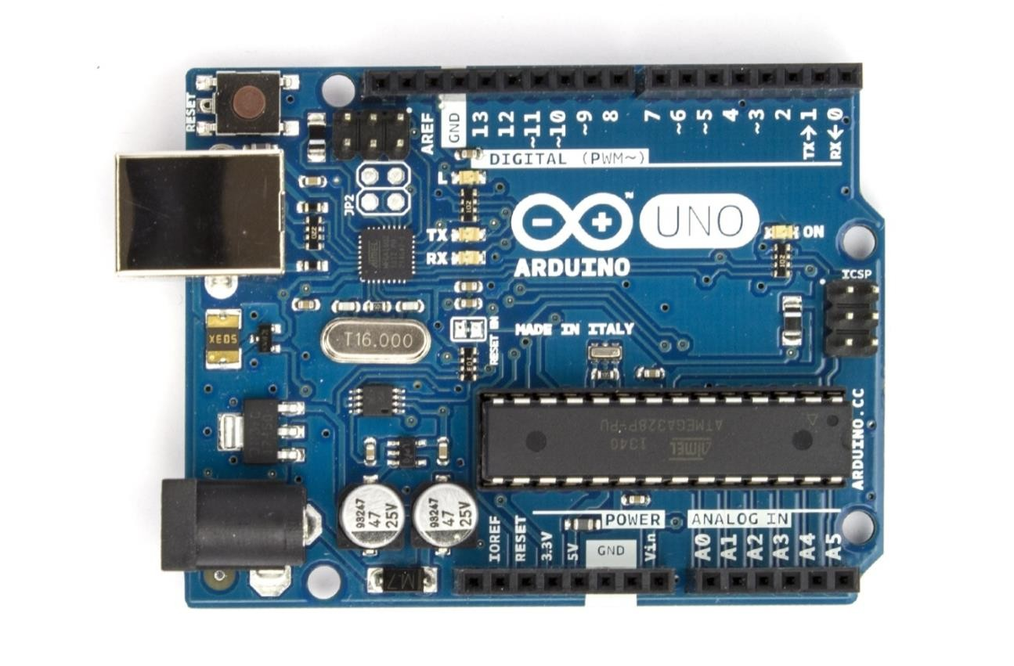
Summary:
Microcontroller ATmega328
Operating Voltage 5V
Input Voltage (recommended) 7-12V
Input Voltage (limits) 6-20V
Digital I/O Pins 14 (of which 6 provide PWM output)
Analog Input Pins 6
DC Current per I/O Pin 40 mA
DC Current for 3.3V Pin 50 mA
Flash Memory 32 KB (ATmega328) of which 0.5 KB used by bootloader
SRAM 2 KB (ATmega328)
EEPROM 1 KB (ATmega328)
Clock Speed 16 MHz

Schematic & Reference Design
EAGLE files: arduino-uno-Rev3-reference-design.zip (NOTE: works with Eagle 6.0 and newer) Schematic: arduino-uno-Rev3-schematic.pdf Note: The Arduino reference design can use an Atmega8, 168, or 328, Current models use an ATmega328, but an Atmega8 is shown in the schematic for reference. The pin configuration is identical on all three processors
Power
The Arduino Uno can be powered via the USB connection or with an external power supply. The power source is selected automatically.
External (non-USB) power can come either from an AC-to-DC adapter (wall-wart) or battery. The
adapter can be connected by plugging a 2.1mm center-positive plug into the board's power jack. Leads from a battery can be inserted in the Gnd and Vin pin headers of the POWER connector.
The board can operate on an external supply of 6 to 20 volts. If supplied with less than 7V, however,
the 5V pin may supply less than five volts and the board may be unstable. If using more than 12V, the voltage regulator may overheat and damage the board. The recommended range is 7 to 12 volts.

The power pins are as follows:
VIN.The input voltage to the Arduino board when it's using an external power source (as opposed to 5 volts from the USB connection or other regulated power source). You can supply voltage through this pin, or, if supplying voltage via the power jack, access it through this pin. 5V.This pin outputs a regulated 5V from the regulator on the board. The board can be supplied with power either from the DC power jack (7 - 12V), the USB connector (5V), or the VIN pin of the board (7-12V). Supplying voltage via the 5V or 3.3V pins bypasses the regulator, and can damage your board. We don't advise it.
3V3. A 3.3 volt supply generated by the on-board regulator. Maximum current draw is 50 mA.
GND. Ground pins.
Memory:
The ATmega328 has 32 KB (with 0.5 KB used for the bootloader). It also has 2 KB of SRAM and 1 KB of EEPROM (which can be read and written with the EEPROM library).
Input and Output:
Each of the 14 digital pins on the Uno can be used as an input or output, using pinMode(), digitalWrite(), and digitalRead() functions. They operate at 5 volts. Each pin can provide or receive a maximum of 40 mA and has an internal pull-up resistor (disconnected by default) of 2050 kOhms. In addition, some pins have specialized functions:
- Serial: 0 (RX) and 1 (TX). Used to receive (RX) and transmit (TX) TTL serial data. These pins are connected to the corresponding pins of the ATmega8U2 USB-to-TTL Serial chip.
- External Interrupts: 2 and 3. These pins can be configured to trigger an interrupt on a low value, a rising or falling edge, or a change in value. See the attachInterrupt() function for details. • PWM: 3, 5, 6, 9, 10, and 11. Provide 8-bit PWM output with the analogWrite() function.
- SPI: 10 (SS), 11 (MOSI), 12 (MISO), 13 (SCK). These pins support SPI communication using the SPI library.
•LED: 13. There is a built-in LED connected to digital pin 13. When the pin is HIGH value, the LED is on, when the pin is LOW, it's off. The Uno has 6 analog inputs, labeled A0 through A5, each of which provide 10 bits of resolution (i.e. 1024 different values). By default they measure from ground to 5 volts, though is it possible to change the upper end of their range using the AREF pin and the analogReference() function. Additionally, some pins have specialized functionality:
- TWI: A4 or SDA pin and A5 or SCL pin. Support TWI communication using the Wire library.
There are a couple of other pins on the board:
•AREF.Reference voltage for the analog inputs. Used with analogReference().
- Reset. Bring this line LOW to reset the microcontroller. Typically used to add a reset button to shields which block the one on the board. See also the mapping between Arduino pins and ATmega328 ports. The mapping for the Atmega8, 168, and 328 is identical.
Communication:
The Arduino Uno has a number of facilities for communicating with a computer, another Arduino, or other microcontrollers. The ATmega328 provides UART TTL (5V) serial communication, which is available on digital pins 0 (RX) and 1 (TX). An ATmega16U2 on the board channels this serial communication over USB and appears as a virtual com port to software on the computer. The '16U2 firmware uses the standard USB COM drivers, and no external driver is needed. However, on Windows, a .inf file is required. The Arduino software includes a serial monitor which allows simple textual data to be sent to and from the Arduino board. The RX and TX LEDs on the board will flash when data is being transmitted via the USB-to-serial chip and USB connection to the computer (but not for serial communication on pins 0 and 1). A SoftwareSerial library allows for serial communication on any of the Uno's digital pins. The ATmega328 also supports I2C (TWI) and SPI communication. The Arduino software includes a Wire library to simplify use of the I2C bus; see the documentation for details. For SPI communication, use the SPI library.

3.2 POWER SUPPLY
The input to the circuit is applied from the regulated power supply. The a.c. input i.e., 230V from the mains supply is step down by the transformer to 12V and is fed to a rectifier. The output obtained from the rectifier is a pulsating d.c voltage. So in order to get a pure d.c voltage, the output voltage from the rectifier is fed to a filter to remove any a.c components present even after rectification. Now, this voltage is given to a voltage regulator to obtain a pure constant dc voltage.
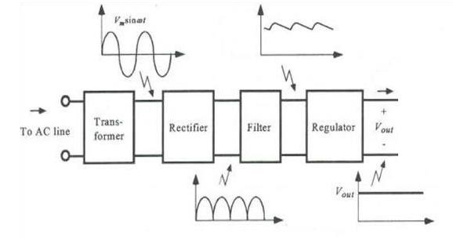
Fig 3.5 Block Diagram of Power supply
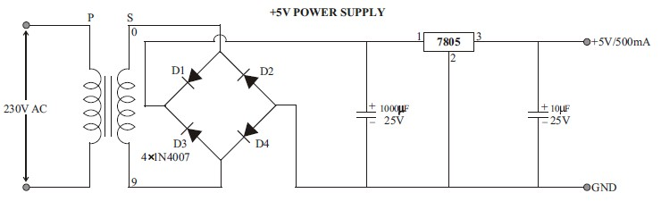

Fig 3.6 Circuit Diagram of Power supply
3.2.1 Step down Transformer:
Usually, DC voltages are required to operate various electronic equipment and these voltages are 5V, 9V or 12V. But these voltages cannot be obtained directly. Thus the a.c input available at the mains supply i.e., 230V is to be brought down to the required voltage level. This is done by a transformer. Thus, a step down transformer is employed to decrease the voltage to a required level.
3.2.2 Rectifier:
The output from the transformer is fed to the rectifier. It converts A.C. into pulsating D.C. The rectifier may be a half wave or a full wave rectifier. In this project, a bridge rectifier is used because of its merits like good stability and full wave rectification.
3.2.3 Filter:
Capacitive filter is used in this project. It removes the ripples from the output of rectifier and smoothens the D.C. Output received from this filter is constant until the mains voltage and load is maintained constant. However, if either of the two is varied, D.C. voltage received at this point changes. Therefore a regulator is applied at the output stage.

3.2.4 Voltage Regulator:
As the name itself implies, it regulates the input applied to it. A voltage regulator is an electrical regulator designed to automatically maintain a constant voltage level. In this project, power supply of 5V and 12V are required. In order to obtain these voltage levels, 7805 and 7812 voltage regulators are to be used. The first number 78 represents positive supply and the numbers 05, 12 represent the required output voltage levels.
Features:
- Output Current up to 1A.
- Output Voltages of 5, 6, 8, 9, 10, 12, 15, 18, 24V.
- Thermal Overload Protection. • Short Circuit Protection.
- Output Transistor Safe Operating Area Protection.
3.3 LCD (LIQUID CRYSTAL DISPLAY)
Liquid Crystal Display also called as LCD is very helpful in providing user interface as well as for debugging purpose. The most commonly used Character based LCDs are based on Hitachi's HD44780 controller or other which are compatible with HD44580. The most commonly used LCDs found in the market today are 1 Line, 2 Line or 4 Line LCDs which have only 1 controller and support at most of 80 characters, whereas LCDs supporting more than 80 characters make use of 2 HD44780 controllers Pin Description:
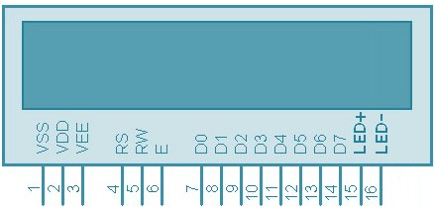

Fig 3.13 Pin Diagram of LCD

Pin No. | Name | Description
1 | VSS | Power supply (GND)
2 | VCC | Power supply (+5V)
3 | VEE | Contrast adjust
4 | RS | - = Instruction input  - = Data input
5 | R/W | - = Write to LCD module  - = Read from LCD module
6 | EN | Enable signal
7 | D0 | Data bus line 0 (LSB)
8 | D1 | Data bus line 1
9 | D2 | Data bus line 2
10 | D3 | Data bus line 3
11 | D4 | Data bus line 4
12 | D5 | Data bus line 5
13 | D6 | Data bus line 6
14 | D7 | Data bus line 7 (MSB)
15 | LED+ | Back Light VCC
16 | LED- | Back Light GND
Table 3.5 Pin Description of LCD
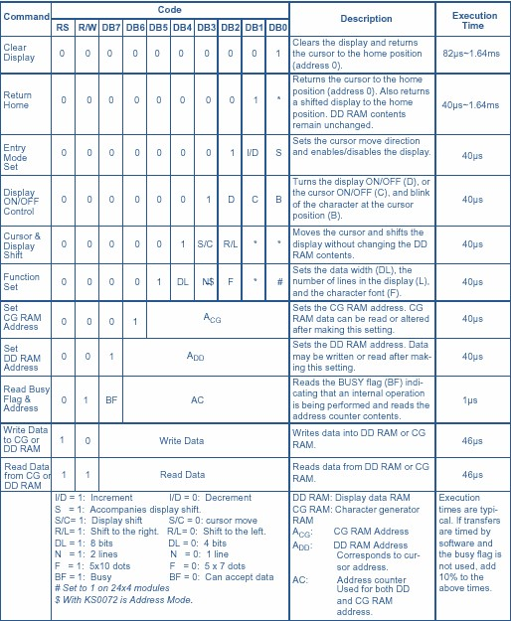

Table3.6 Command Operation of LCD
Although looking at the table you can make your own commands and test them. Below is a brief list of useful commands which are used frequently while working on the LCD.
No. | Instruction |  | Hex |  | Decimal
1 | Function Set: 8-bit, 1 Line, 5x7 Dots |  | 0x30 |  | 48
2 | Function Set: 8-bit, 2 Line, 5x7 Dots | 0x38 |  | 56
3 | Function Set: 4-bit, 1 Line, 5x7 Dots | 0x20 |  | 32
4 | Function Set: 4-bit, 2 Line, 5x7 Dots | 0x28 |  | 40
5 | Entry Mode | 0x06 |  | 6
6 | Display off Cursor off  (clearing display without clearing DDRAM content) | 0x08 |  | 8
7 | Display on Cursor on | 0x0E |  | 14
8 | Display on Cursor off | 0x0C |  | 12
9 | Display on Cursor blinking | 0x0F |  | 15
10 | Shift entire display left | 0x18 |  | 24
12 | Shift entire display right | 0x1C |  | 30
13 | Move cursor left by one character | 0x10 |  | 16
14 | Move cursor right by one character | 0x14 |  | 20
15 | Clear Display (also clear DDRAM content) | 0x01 |  | 1
16 | Set DDRAM address or cursor position on display | 0x80+add |  | 128+add
17 | Set CGRAM address or set pointer to  CGRAM location | 0x40+add |  | 64+add
Table 3.7 Command List of LCD
Sending Commands to LCD
To send commands we simply need to select the command register. Everything is same as we have done in the initialization routine. But we will summarize the common steps and put them in a single subroutine. Following are the steps:
- move data to LCD port
- select command register
- select write operation
- send enable signal
- wait for LCD to process the command
- Sending Data to LCD
- To send data move data to LCD port
- select data register • select write operation.
3.4 IR SENSOR:
IR Transmitter:

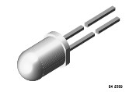
TSAL6200 is a high efficiency infrared emitting diode in GaAlAs on GaAs technology, molded in clear, blue grey tinted plastic packages. In comparison with the standard GaAs on GaAs technology these emitters achieve more than 100 % radiant power improvement at a similar wavelength. The forward voltages at low current and at high pulse current roughly correspond to the low values of the standard technology. Therefore these emitters are ideally suitable as high performance replacements of standard emitters.

Features
- Extra high radiant power and radiant intensity.
- High reliability.
- Low forward voltage.
- Suitable for high pulse current operation.
- Standard T-1¾ ( 5 mm) package.
- Angle of half intensity ϕ = ± 17°.
- Peak wavelength λp = 940 nm.
- Good spectral matching to Silicon photodetectors.

Applications
Infrared remote control units with high power requirements
Free air transmission systems
Infrared source for optical counters and card readers
IR source for smoke detectors.

IR Receiver:
The TSOP17.. – series are miniaturized receivers for infrared remote control systems. PIN diode and preamplifier are assembled on lead frame, the epoxy package is designed as IR filter. The demodulated output signal can directly be decoded by a microprocessor. TSOP17XX is the standard IR remote control receiver series, supporting all major transmission codes.

Features
- Photo detector and preamplifier in one package.
- Internal filter for PCM frequency.
- Improved shielding against electrical field disturbance.
- TTL and CMOS compatibility.
- Output active low.
- Low power consumption.
- High immunity against ambient light.
- Continuous data transmission possible (up to 2400 bps).
- Suitable burst length .10 cycles/burst

Block Diagram

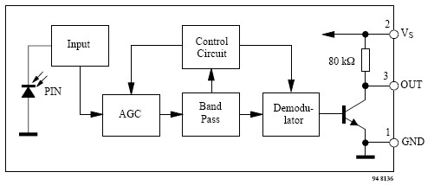

Application Circuit

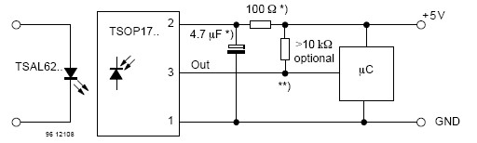

The circuit of the TSOP17.. is designed in such a way that unexpected output pulses due to noise or disturbance signals are avoided. A bandpassfilter, an integrator stage and an automatic gain control are used to suppress such disturbances. The distinguishing mark between data signal and disturbance signal are carrier frequency, burst length and duty cycle. The data signal should fulfill the following condition:
- Carrier frequency should be close to center frequency of the band pass (e.g. 38kHz).
- Burst length should be 10 cycles/burst or longer.
- After each burst which is between 10 cycles and 70 cycles a gap time of at least 14 cycles is necessary.
- For each burst which is longer than 1.8ms a corresponding gap time is necessary at some time in the data stream. This gap time should have at least same length as the burst.
- Up to 1400 short bursts per second can be received continuously.
When a disturbance signal is applied to the TSOP17.. it can still receive the data signal. However the sensitivity is reduced to that level that no unexpected pulses will occur.
The arrangement of this sensors is as shown below.
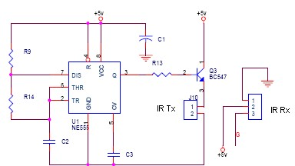

3.5 SERVO MOTOR
A servo motor is a type of motor that can rotate with great precision. Normally this type of motor consists of a control circuit that provides feedback on the current position of the motor shaft, this feedback allows the servo motors to rotate with great precision. If you want to rotate an object at some specific angles or distance, then you use a servo motor. It is just made up of a simple motor which runs through a servo mechanism. If motor is powered by a DC power supply then it is called DC servo motor, and if it is AC-powered motor then it is called AC servo motor. For this tutorial, we will be discussing only about the DC servo motor working. Apart from these major classifications, there are many other types of servo motors based on the type of gear arrangement and operating characteristics. A servo motor usually comes with a gear arrangement that allows us to get a very high torque servo motor in small and lightweight packages. Due to these features, they are being used in many applications like toy car, RC helicopters and planes, Robotics, etc.
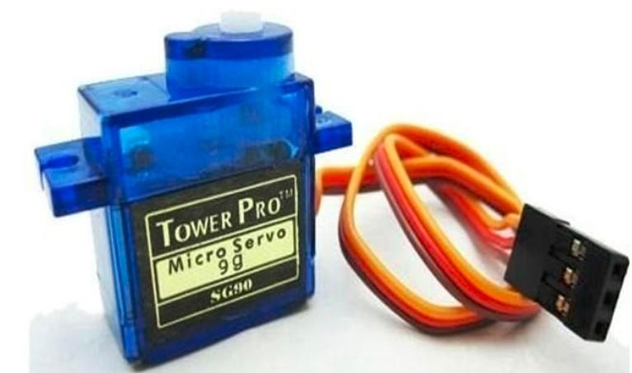
Servo motors are rated in kg/cm (kilogram per centimeter) most hobby servo motors are rated at 3kg/cm or 6kg/cm or 12kg/cm. This kg/cm tells you how much weight your servo motor can lift at a particular distance. For example: A 6kg/cm Servo motor should be able to lift 6kg if the load is suspended 1cm away from the motors shaft, the greater the distance the lesser the weight carrying capacity. The position of a servo motor is decided by electrical pulse and its circuitry is placed beside the motor.
Servo Motor Working Mechanism
It consists of three parts:
- Controlled device
- Output sensor
- Feedback system
It is a closed-loop system where it uses a positive feedback system to control motion and the final position of the shaft. Here the device is controlled by a feedback signal generated by comparing output signal and reference input signal.
Here reference input signal is compared to the reference output signal and the third signal is produced by the feedback system. And this third signal acts as an input signal to the control the device. This signal is present as long as the feedback signal is generated or there is a difference between the reference input signal and reference output signal. So the main task of servomechanism is to maintain the output of a system at the desired value at presence of noises.

Servo Motor Working Principle
A servo consists of a Motor (DC or AC), a potentiometer, gear assembly, and a controlling circuit. First of all, we use gear assembly to reduce RPM and to increase torque of the motor. Say at initial position of servo motor shaft, the position of the potentiometer knob is such that there is no electrical signal generated at the output port of the potentiometer. Now an electrical signal is given to another input terminal of the error detector amplifier. Now the difference between these two signals, one comes from the potentiometer and another comes from other sources, will be processed in a feedback mechanism and output will be provided in terms of error signal. This error signal acts as the input for motor and motor starts rotating. Now motor shaft is connected with the potentiometer and as the motor rotates so the potentiometer and it will generate a signal. So as the potentiometer’s angular position changes, its output feedback signal changes. After sometime the position of potentiometer reaches at a position that the output of potentiometer is same as external signal provided. At this condition, there will be no output signal from the amplifier to the motor input as there is no difference between external applied signal and the signal generated at potentiometer, and in this situation motor stops rotating.
Interfacing Servo Motors with Microcontrollers:
Interfacing hobby Servo motors like s90 servo motor with MCU is very easy. Servos have three wires coming out of them. Out of which two will be used for Supply (positive and negative) and one will be used for the signal that is to be sent from the MCU. An MG995 Metal Gear Servo Motor which is most commonly used for RC cars humanoid bots etc.
The color coding of your servo motor might differ hence check for your respective datasheet.
All servo motors work directly with your +5V supply rails but we have to be careful on the amount of current the motor would consume if you are planning to use more than two servo motors a proper servo shield should be designed.
Controlling Servo Motor:
All motors have three wires coming out of them. Out of which two will be used for Supply (positive and negative) and one will be used for the signal that is to be sent from the MCU.
Servo motor is controlled by PWM (Pulse with Modulation) which is provided by the control wires. There is a minimum pulse, a maximum pulse and a repetition rate. Servo motor can turn 90 degree from either direction form its neutral position. The servo motor expects to see a pulse every 20 milliseconds (ms) and the length of the pulse will determine how far the motor turns. For example, a 1.5ms pulse will make the motor turn to the 90° position, such as if pulse is shorter than 1.5ms shaft moves to 0° and if it is longer than 1.5ms than it will turn the servo to 180°.
Servo motor works on PWM (Pulse width modulation) principle, means its angle of rotation is controlled by the duration of applied pulse to its Control PIN. Basically servo motor is made up of DC motor which is controlled by a variable resistor (potentiometer) and some gears. High speed force of DC motor is converted into torque by Gears. We know that WORK= FORCE X DISTANCE, in DC motor Force is less and distance (speed) is high and in Servo, force is High and distance is less. The potentiometer is connected to the output shaft of the Servo, to calculate the angle and stop the DC motor on the required angle.

4. ARDUINO SOFTWARE
Arduino IDE (Integrated Development Environment) is required to program the Arduino Uno board. Download it here.

PROGRAMMING ARDUINO
Once arduino IDE is installed on the computer, connect the board with computer using USB cable.
Now open the arduino IDE and choose the correct board by selecting
Tools>Boards>Arduino/Genuino Uno, and choose the correct Port by selecting Tools>Port. Arduino Uno is programmed using Arduino programming language based on Wiring. To get it started with Arduino Uno board and blink the built-in LED, load the example code by selecting Files>Examples>Basics>Blink. Once the example code (also shown below) is loaded into your
IDE, click on the ‘upload’ button given on the top bar. Once the upload is finished, you should see the Arduino’s built-in LED blinking. Below is the example code for blinking:

ARDUINO – INSTALLATION
After learning about the main parts of the Arduino UNO board, we are ready to learn how to set up the Arduino IDE. Once we learn this, we will be ready to upload our program on the Arduino board.
In this section, we will learn in easy steps, how to set up the Arduino IDE on our computer and prepare the board to receive the program via USB cable.
Step 1: First you must have your Arduino board (you can choose your favorite board) and a USB cable. In case you use Arduino UNO, Arduino Duemilanove, Nano, Arduino Mega 2560, or Diecimila, you will need a standard USB cable (A plug to B plug), the kind you would connect to a USB printer as shown in the following image.
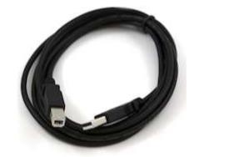
In case you use Arduino Nano, you will need an A to Mini-B cable instead as shown in the following image

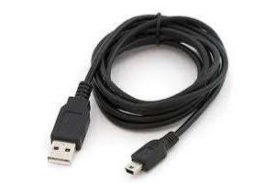

Step 2: Download Arduino IDE Software.
You can get different versions of Arduino IDE from the Download page on the Arduino Official website. You must select your software, which is compatible with your operating system (Windows, IOS, or Linux). After your file download is complete, unzip the file.
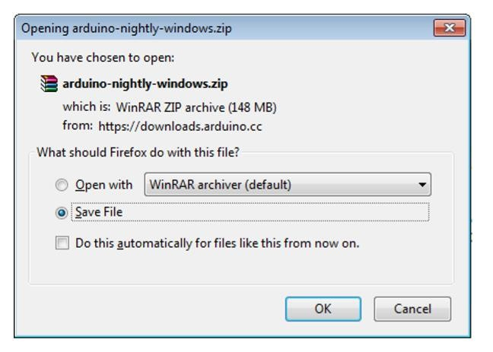
Step 3: Power up your board.
The Arduino Uno, Mega, Duemilanove and Arduino Nano automatically draw power from either, the USB connection to the computer or an external power supply. If you are using an Arduino Diecimila, you have to make sure that the board is configured to draw power from the USB connection. The power source is selected with a jumper, a small piece of plastic that fits onto two of the three pins between the USB and power jacks. Check that it is on the two pins closest to the USB port.
Connect the Arduino board to your computer using the USB cable. The green power LED (labeled PWR) should glow.

Step 4: Launch Arduino IDE.
After your Arduino IDE software is downloaded, you need to unzip the folder. Inside the folder, you can find the application icon with an infinity label (application.exe). Doubleclick the icon to start the IDE
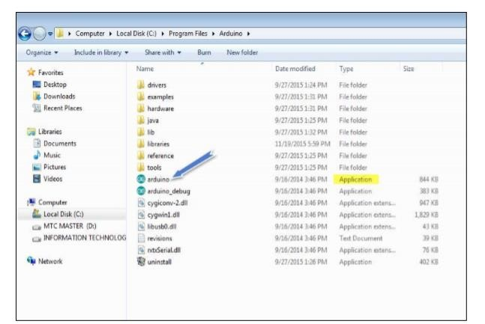
Step 5: Open your first project.
Once the software starts, you have two options:
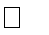
Create a new project.
Open an existing project example.
To create a new project, select File --> New
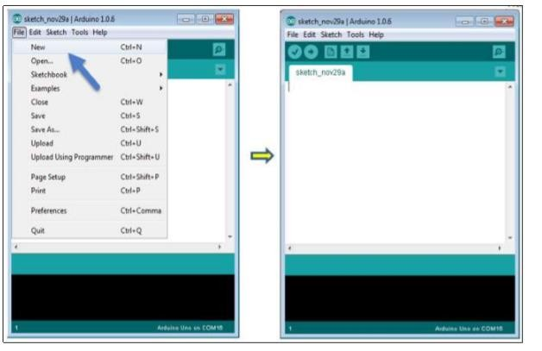
To open an existing project example, select File -> Example -> Basics -> Blink.
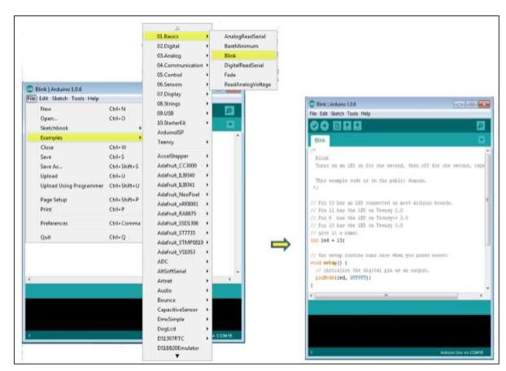
Here, we are selecting just one of the examples with the name Blink. It turns the LED on and off with some time delay. You can select any other example from the list.
Step 6: Select your Arduino board.
To avoid any error while uploading your program to the board, you must select the correct Arduino board name, which matches with the board connected to your computer.
Go to Tools -> Board and select your board.

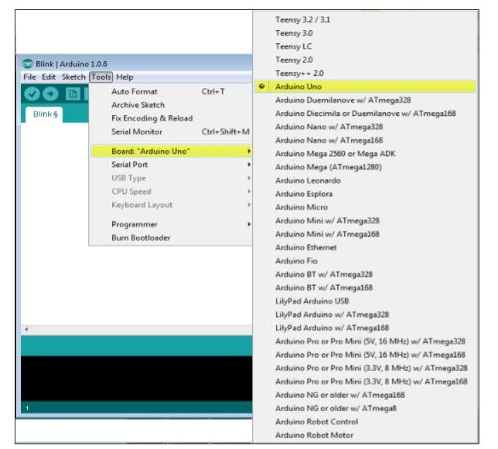
Here, we have selected Arduino Uno board according to our tutorial, but you must select the name matching the board that you are using.

Step 7: Select your serial port.
Select the serial device of the Arduino board. Go to Tools -> Serial Port menu. This is likely to be COM3 or higher (COM1 and COM2 are usually reserved for hardware serial ports). To find out, you can disconnect your Arduino board and re-open the menu, the entry that disappears should be of the Arduino board. Reconnect the board and select that serial port.
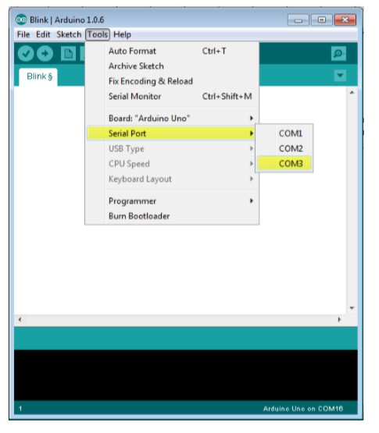

Step 8: Upload the program to your board.
Before explaining how we can upload our program to the board, we must demonstrate the function of each symbol appearing in the Arduino IDE toolbar
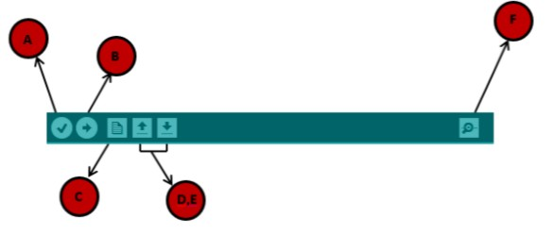
- Used to check if there is any compilation error.
- Used to upload a program to the Arduino board.
- Shortcut used to create a new sketch.
- Used to directly open one of the example sketch.
- Used to save your sketch.
- Serial monitor used to receive serial data from the board and send the serial data to the board.
Now, simply click the "Upload" button in the environment. Wait a few seconds; you will see the RX and TX LEDs on the board, flashing. If the upload is successful, the message "Done uploading" will appear in the status bar.
Note: If you have an Arduino Mini, NG, or other board, you need to press the reset button physically on the board, immediately before clicking the upload button on the Arduino Software.

ARDUINO – PROGRAM STRUCTURE
we will study in depth, the Arduino program structure and we will learn more new terminologies used in the Arduino world. The Arduino software is open-source. The source code for the Java environment is released under the GPL and the C/C++ microcontroller libraries are under the LGPL.
Sketch: The first new terminology is the Arduino program called “sketch”.
Structure Arduino programs can be divided in three main parts: Structure, Values (variables and constants), and Functions. In this tutorial, we will learn about the Arduino software program, step by step, and how we can write the program without any syntax or compilation error.
Let us start with the Structure. Software structure consist of two main functions:
Setup( ) function
Loop( ) function
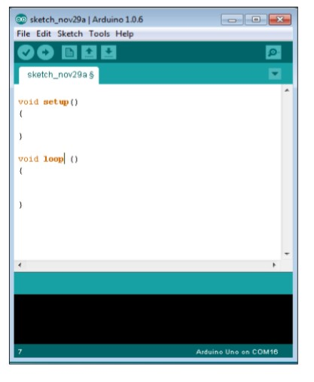
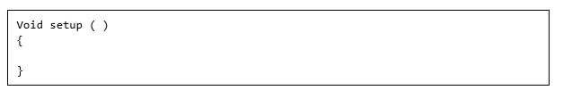
PURPOSE: The setup() function is called when a sketch starts. Use it to initialize the variables, pin modes, start using libraries, etc. The setup function will only run once, after each power up or reset of the Arduino board.
INPUT: - OUTPUT: - RETURN:
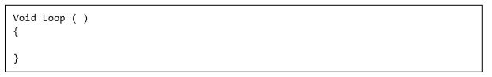
PURPOSE: After creating a setup() function, which initializes and sets the initial values, the loop() function does precisely what its name suggests, and loops consecutively, allowing your program to change and respond. Use it to actively control the Arduino board.
INPUT: - OUTPUT: -
RETURN:

5.RESULT

ADD HARDWARE KIT PHOTOS

6. CONCLUSION
Automatic railway gate control system is centered on the idea of reducing human involvement for closing and opening the railway gate which allows and prevents accidents near level crossing. The railway gate is a cause of many deaths and accidents. Hence, automating the gate can bring about a ring of surety to controlling the gates. Human may make errors or mistakes so automating this process will reduce the chances of gate failures and reduces the errors made by gate keepers. The accidents are avoided at place where there is no person to manage the railway crossing gates. Here we use the servo motor to open and close the gates automatically when it rotates clockwise or anticlockwise direction to operate the gate automatically. In the obstacle detection part the ultrasonic sensor sensed the obstacle and the train stops as soon as the obstacle detection message is conveyed to the nearby railway station as well as for the train operator. So through this system any obstacle on track can be detected and accident can be avoided and also the message as been conveyed to the concerned.

FUTURE WORK
The accidents due to railway level crossing and the obstacle can be avoided in real time by implementing this system and the whole process is completely automatic. In future the features like wireless system can be implemented in the real time operation. In real time operation vibration sensors can be used in place of IR sensors for the detection of arrival and departure of train. So the vibration sensor serves better when compared to the IR sensors for the real time.

7. BIBLIOGRAPHY
[1]. R.Gopinathan and B.Sivashankar, “PLC based railway level crossing gate control”, International Journal of Emerging Technology in Computer Science & Electronics (IJETCSE).
ISSN: 0976-1353 Volume 8 Issue 1 –April 2014.
[2]. Pradeep Raj, “Increasing accidents in the unmanned level crossing of the railways”, 2012. [3]. Xishi Wang, Ning Bin, and Cheng Yinhang, “A new microprocessor based approach to an automatic control system.” International Symposium on Industrial Electronics, pp. 842-843, 1992. [4]. Jeong Y., Choon-Sung Nam, Hee-Jin Jeong, and Dong Shin, “Train Auto Control System based on OSGI”, International Conference on Advanced Communication Technology, pp.276279, 2008.
[5]. KSCSE, KSCSE library: “Railway track monitoring system”, project report.
[6]. Sangita N.Guja, Jagruti R.Panchal, Lalita K.Wani, “Improving safety with obstacle detection and track following car using sensor, GPS and GSM”, International Journal of Research in Engineering and Technology.
[7]. www.arduino.cc/reference
[8]. Karthik, Krishnamurthi, Monica Bobby, Vidya V, “Sensor based automatic control of railway gates”, International Journal of Advanced Research in Computer Engineering & Technology.

